**User Guide**

CIS 4911 – Senior Project

Virtual Queue

**Member:**

Kenneth Kon

Michael Lazo

**Instructor**

Masoud Sadjadi

**Mentor**

[Bernard Parenteau](http://spws-dev.cis.fiu.edu/senior-project-website-v4/user/231)

**Date**

April 27st 2015

Copyright © Florida International University 2015. All Rights Reserved. No part of the Virtual Queue Project or documentation may be reproduced or modified without the express consent of Florida International University, School of Computing & Information Sciences. Redistribution or commercial use is strictly prohibited. The Software is provided “AS IS”, without warranty of any kind, express or implied, including but not limited to the warranties of merchantability, fitness for a particular purpose, if no event shall the authors or copyright holders be liable for any claim, damage or other liability.

# Introduction

The Virtual Queue system allows users to virtually line up to an activity without physically waiting in line. This lets users to freely do something more entertaining without waiting there time. This document contains on the hardware and software requirement for the system, how to install and setup the system. It also contain information how to run the application.

# Hardware and Software Requirements:

1. **Safari 7.0.6:** last, most updated version of the Safari browser that will be used to test Virtual Queue.
2. **Google Chrome 37.0:** last, most updated version of the Google Chrome browser that will be used to test Virtual Queue.
3. **Spring Framework 4.0:** last, most updated version of Spring Framework, an MVC-based, Java framework used for development. It will be used to develop the front-end and back-end of Virtual Queue.
4. **Quartz Scheduler**: open source job scheduling library that can be integrated within virtually any Java application. It will be used to create, start, stop jobs, and send notifications and delete users from rides.
5. **Bootstrap 3**: most popular HTML, CSS, and JS framework for developing responsive, mobile first projects on the web. It will be used for the front-end design development.
6. **Spring JDBC template**: make database call access to MySQL database.
7. **JQuery**: Fast, small, and feature-rich JavaScript library. It will be used to connect the front-end development with the back-end development.
8. **MySQL**: database that will be used to store data for the Virtual Queue system.
9. **Cacoo:** UML web application that is used to create diagrams for the document.
10. **VMWare:** virtual machine software that will be used for the deployment of the software.
11. **Eclipse Luna:** IDETool software used to write the java classes for the Virtual Queue system.
12. **Tomcat 8.0**: Java J2EE Application Server used to deploy and run the Virtual Queue system.

# Installation and setup

## 1.1 Install JDK 7

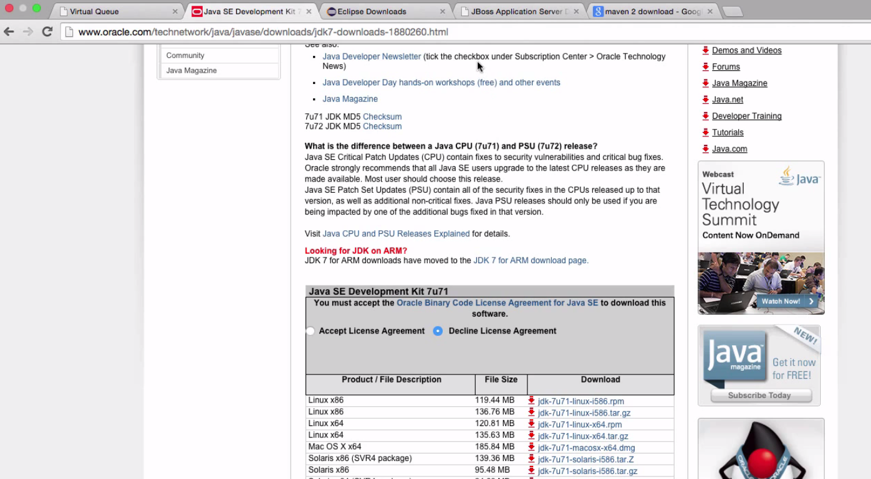

Link: http://www.oracle.com/technetwork/java/javase/downloads/jdk7-downloads-1880260.html

## 1.2 Install Eclipse IDE for Java EE Developers (Any Version)

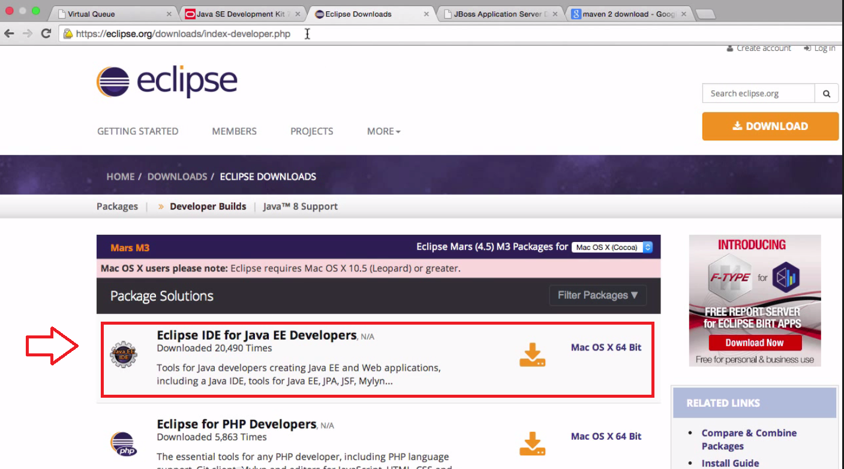

* Link: http://eclipse.org/downloads/

## 1.3 Download tomcat 8.0

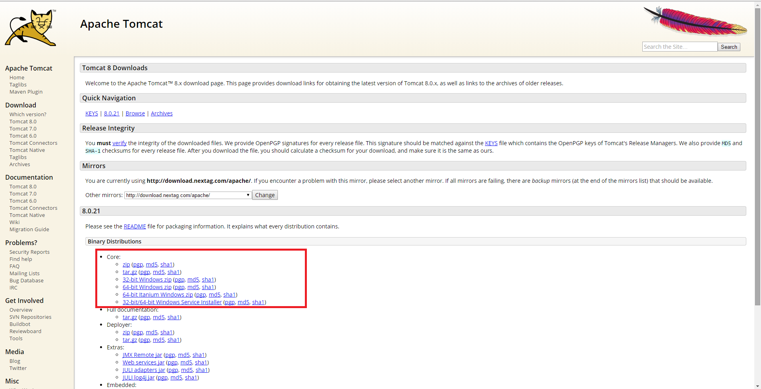

* Download Tomcat 8.0 version from https://tomcat.apache.org/download-80.cgi
* Then create a new server in Server Tab in Eclipse you have downloaded.
* Create Tomecat 8.0 Server version attach Tomcat 8.0 file as Server runtime environment.

## 1.4 Create Tomcat 8.0 server in eclipse using Tomcat 8.0

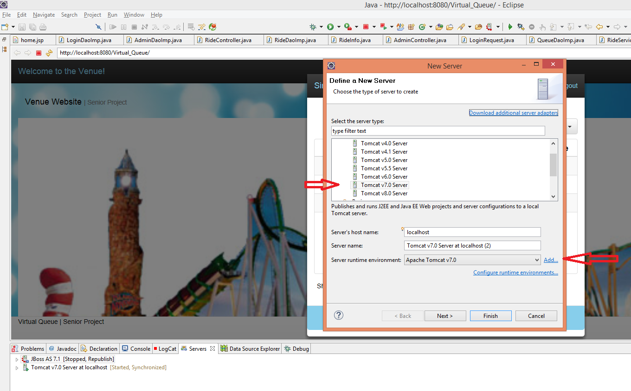

* Click on create new server in "Servers" tab in eclipse.
* Then create Tomcat Server 8.0 servers and attach 1.7.1 file to Serve runtime environment.

## 1.5 Download MySQL installer community and Workbench

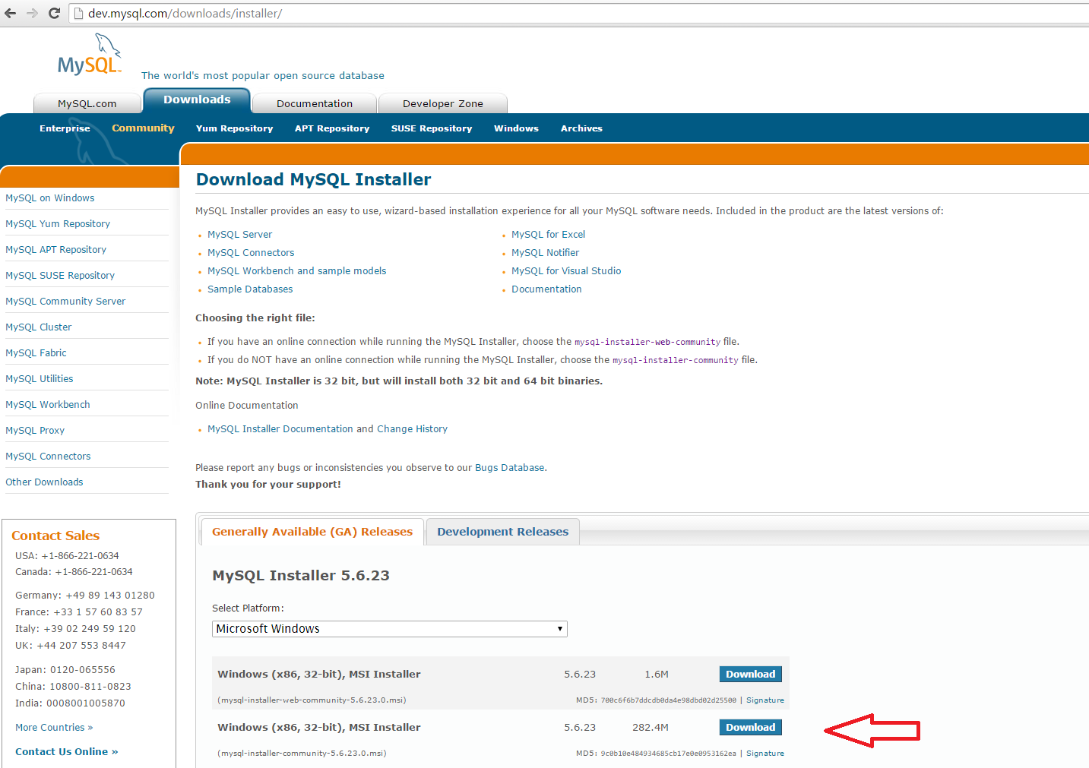

* Follow the direction given to you by the installer
* Create the existing database design in workbench. Database name should be "vqdatabase"
* Link: https://dev.mysql.com/downloads/installer/

# Getting Started - How to run Virtual Queue System

## Virtual Queue Homepage:

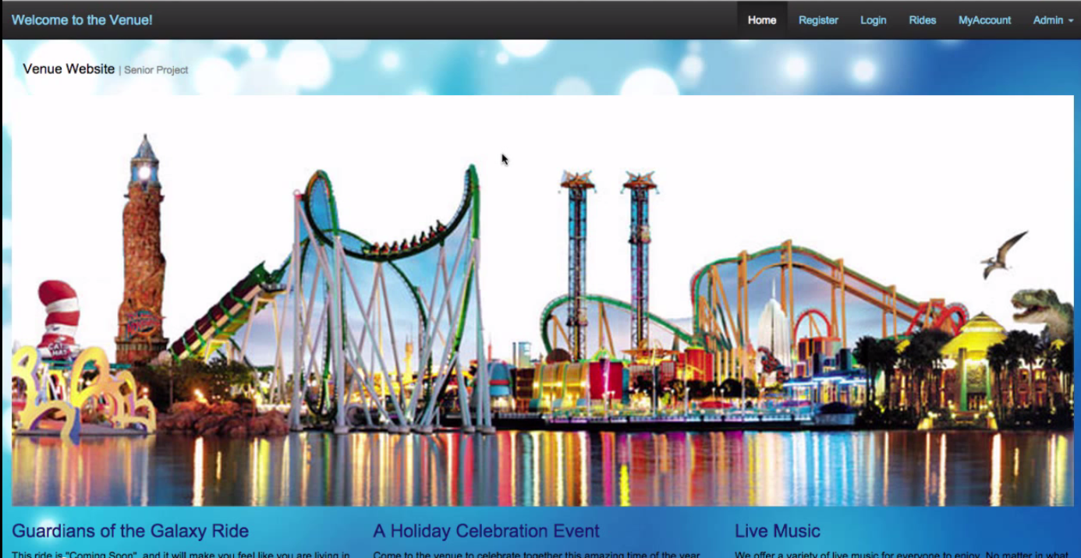

## 1. How to Register?

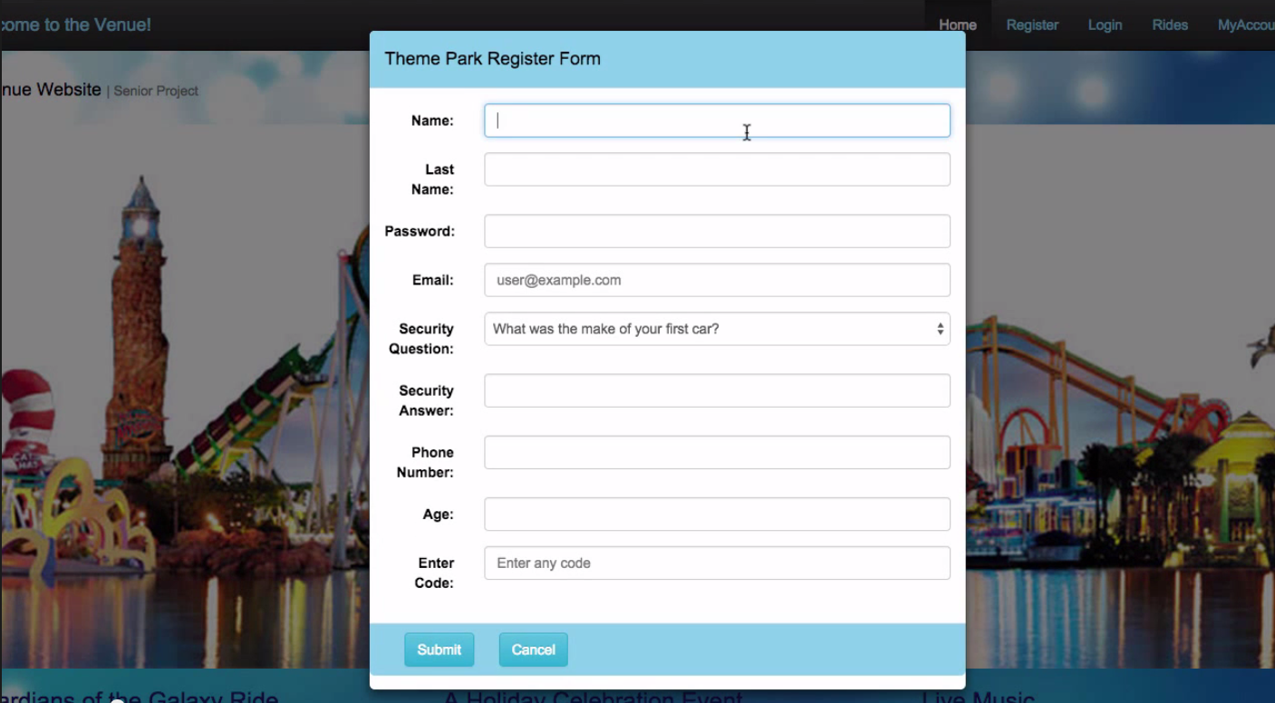

1) Click on Register tab on the top right hand corner of the homepage.

2) Fill in the "Theme Park Register Form"

3) Then press submit.

4) There you are now you are registered!

## 2. How to Login?

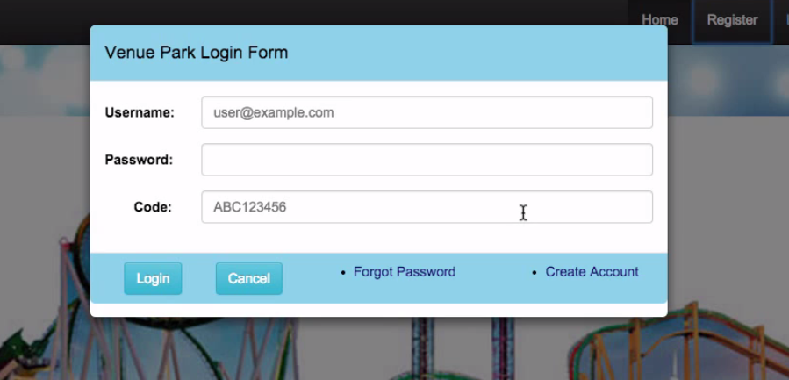

1) Press the Log In tab on top right hand corner of the home page.

2) Fill in the "Veneue Park Login Form", with appropriate Username, Password and Code.

3) Then press "Login"

## 3. How to Reset Password?

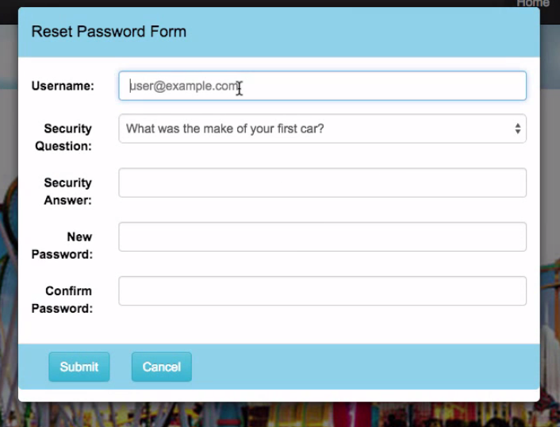

1) Forget your password? Then press the "Forgot Password" link right next to the "Cancel" button in the "Venue Park Login Forum".

2) Then fell out the "Reset Password Form", with appropriate value to change your password.

3) Lastly press Submit then your password is saved to new password.

# 4. How to How to check available Rides & Queue to a Ride?

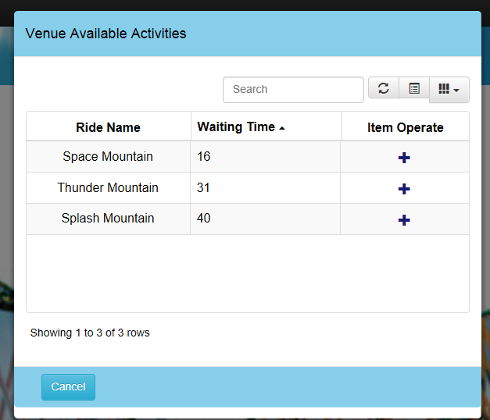

1) Click on "Rides" tab on the home page.

2) "Venue Available Activities" will pop up.

* Ride Name - shows the name of the rides that's available
* Waiting Time - shows how long you have to wait if you queue up to the ride
* Item Operate - the plus button allows you to add yourself to line up to that ride

3) By clicking on the plus button, the user who is logged in can queue themselves to wait in that line.

4) When you queue up to a ride, you will receive a email notification, containing information on your ride name and estimated wait time.

# 5. As a Visitor how to check what rides I am queued to?

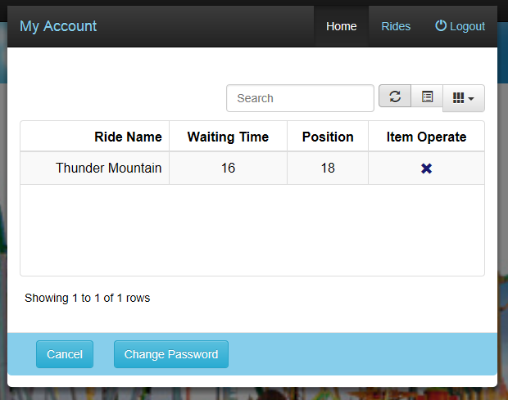

1) When logged into your own login, click My Account button on top right hand corner of the home page.

2) "My Account" window will pop up.

* Ride Name - shows the name of the rides that's available
* Waiting Time - estimated time until you can get onto the ride
* Position - What position you are in the line.
* Item Operate - X button is remove from queue button. Allows you to remove yourself from the queue

3) You will receive a notification, when waiting time becomes less than 10 minutes.

Sample Notification Email:

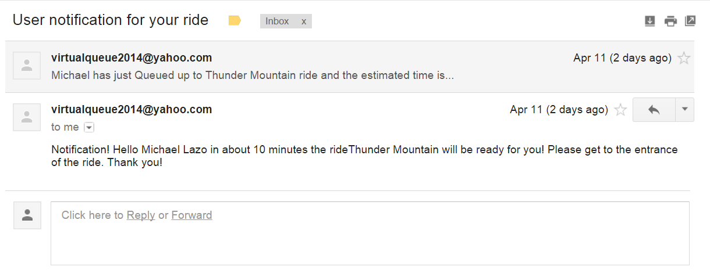

# 6. How to Login as a Admin?

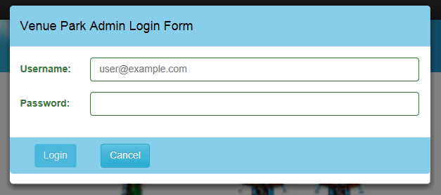

1) Click on "Admin" tab on top right hand corner of the homepage.

2) Then click on Login button.

3) Fill out "Venue Park Admin Login Form"

4) Press "Login" button

# 7. How to How to check available Rides, Queue to a Ride & Dequeue rides?

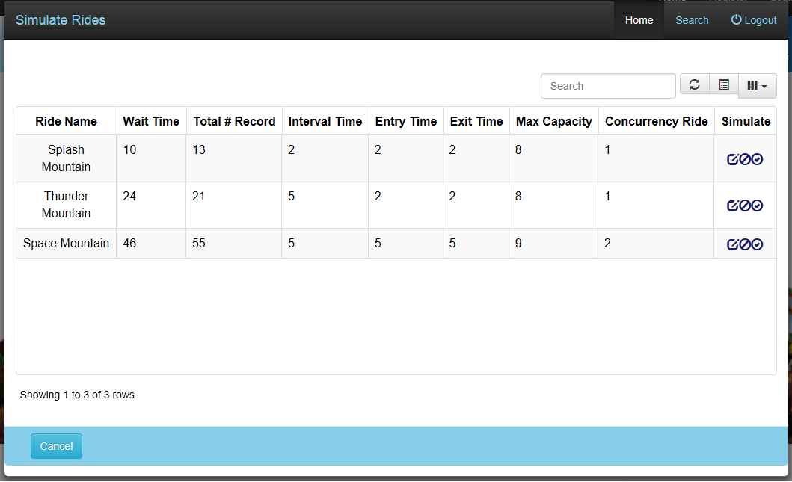

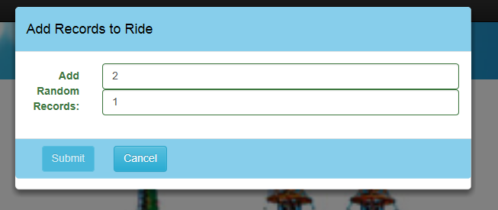

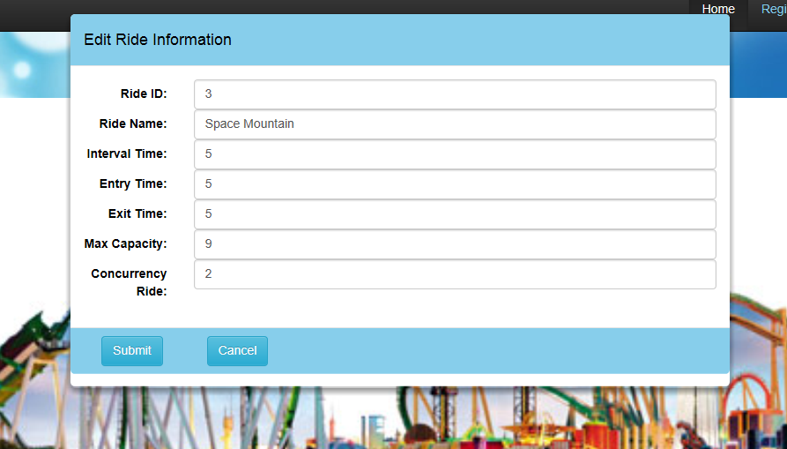

1) Click on "Admin" tab on top right hand corner of the homepage.

2) Then click "Simulate Ride" button.

3) Simulate Ride window will appear, with Simulate Ride table.

* Ride Name - name of the rides in the venue
* Wait Time - (in Minute) total wait time for that current ride
* Total # of records - Total number of records that is currently queued to that ride
* Interval Time - (in Minute) average time each ride takes to complete
* Entry Time - (in Minute) average time it takes to get visitors get on the ride
* Exit Time - (in Minute) average time it takes to get quest off the ride
* Max Capacity - max number of visitors that can get on for each interval
* Concurrency Ride - number of rides simultaneously happening per Interval
* Simulate
  + First button - "Add records" allows admin to add random visitors to the queue
  + Second button - "Dequeue" allows admin to dequeue max capacity of rides to a ride.
  + Third button - "Edit" allows admin to edit the ride information within the table.

4) When pressing "Add records" button in simulate add records ride will show up.

5) In the first textbox fill in 0-100 number to select how many records you want to add to that ride. The press submit. This should update the # of records and time of the ride you have added too.

6) To simulate dequeue of the ride, click on the "Dequeue" button next to "Add Records" button in the Simulate column of the table. Then it would dequeue the rides by max capacity of the rides.

7) When pressing the "Edit" button the "Edit Ride Information" window will pop up. In this window you can edit the according information for a particular ride you want to edit. Then you can save the information by pressing the "Submit" button. If you want not want to change anything then press the "Cancel" button.

# Quick Reference

* VQ-Requirement Document: contains requirement on Virtual Queue System
* VQ-Design Document: contains design of the subsystem of the Virtual Queue system
* VQ-Feasibility and Project Plan Document: contains what is feasible and schedule of what was worked on for Virtual Queue 2.0.

# Accessing Online Help

None

# References

Images used:

1. <http://www.plan-family-reunions.com/themeParks.html>
2. http://ru.forwallpaper.com/wallpaper/abstract-circles-patterns-dots-light-colors-bokeh-abstraction-172728.html